Instructions for tool.box software use:

Step 1 The user enters the file description
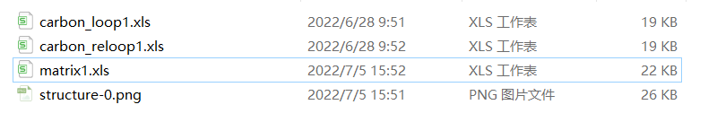
Figure 1 User input file

There are three user input needed for our algorithm to work:
- The adjacent matrix of the graphene structure.
- The information of valid double bond combination in each ring to form a benzene ring.
- The information of the neighbor rings for each ring.
（All file types are XLS files, as shown in Figure 1）
（*Please refer to the examples given in the input file）
（1）adjacent matrix：
Users need to input the adjacency matrix of the structure：the adjacent matrix describes the connectivity inside the graphene structure, where 1 means two atoms are connected and 0 means not. An adjacent matrix is as shown in figure 2.
（2）carbon_loop：
It records for each ring what are the valid double bond combination for it to be a benzene ring as shown in figure 2.
- carbon_reloop：
It records the adjacent neighbors of each ring including itself to ensure the constrain of two rings next to each other cannot be benzene rings at the same time.
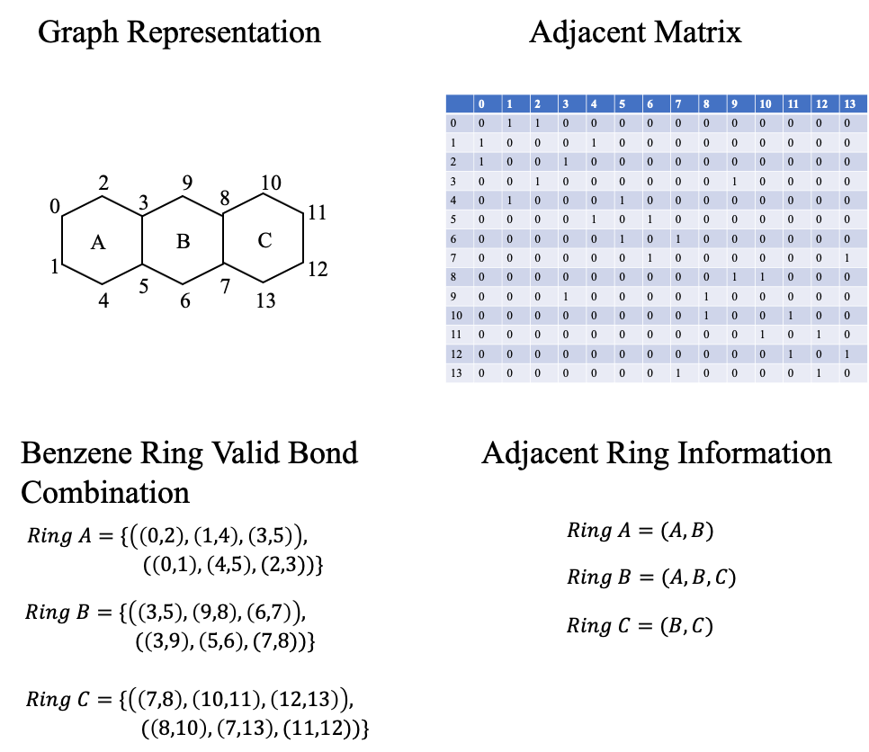
Figure 2

Step 2 Use instructions
- 文件输入
分别依次按照提示选择要输入的文件：
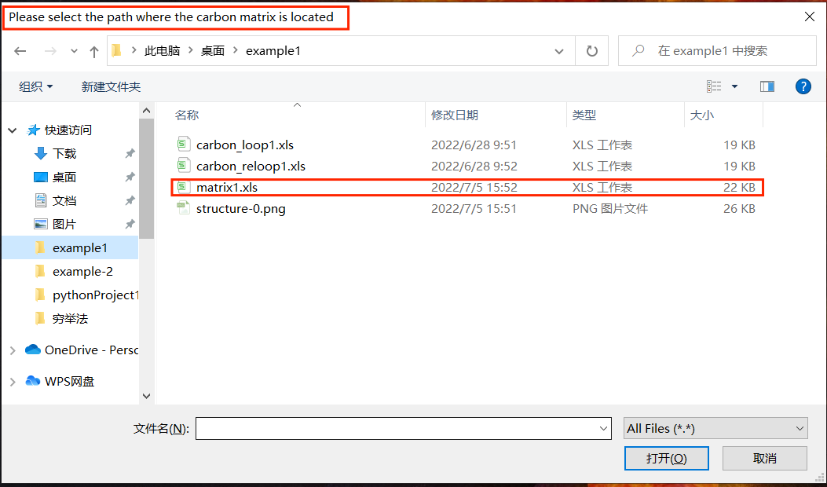

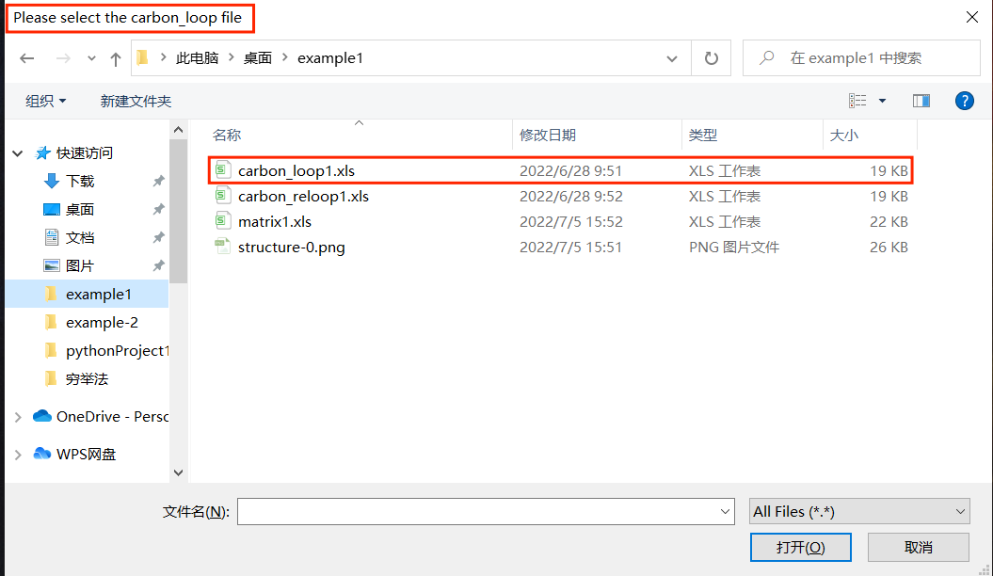

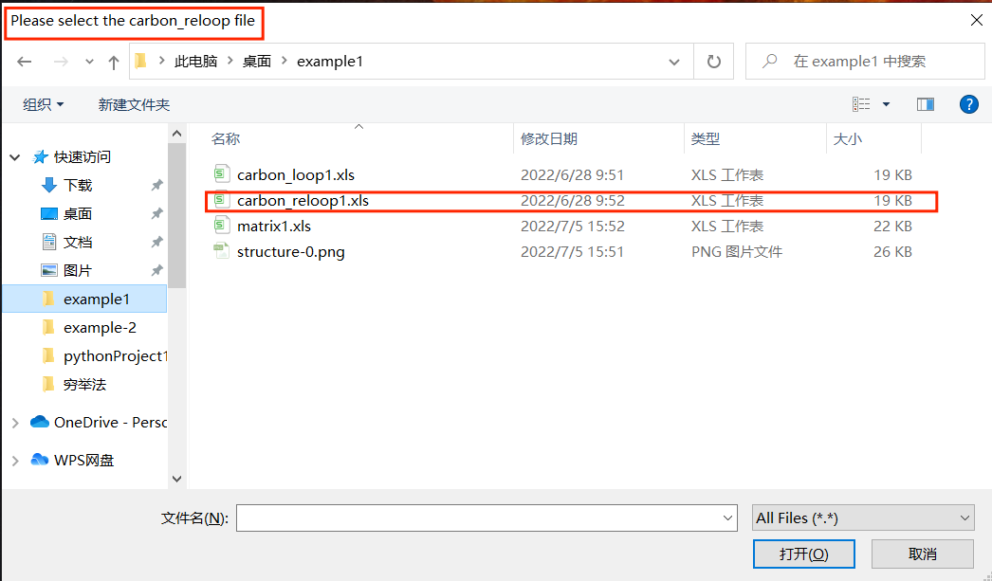

- Select Function
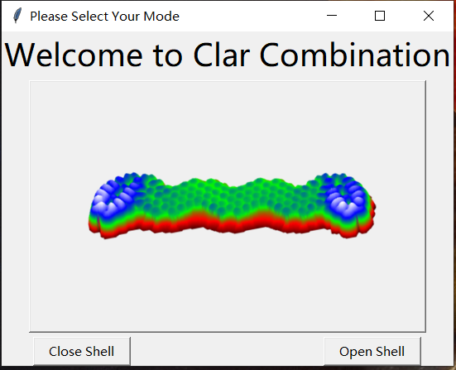
Close shell：closed-shell benzenoid structures(no free radicals)
Open shell：open-shell benzenoid structures(With two free radicals)

- Select Mode
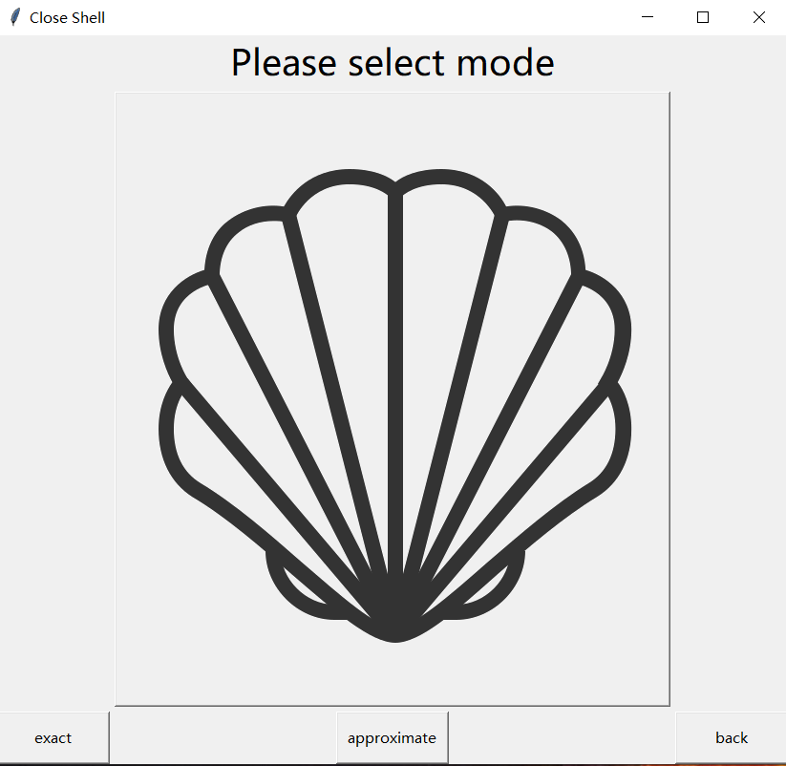 | 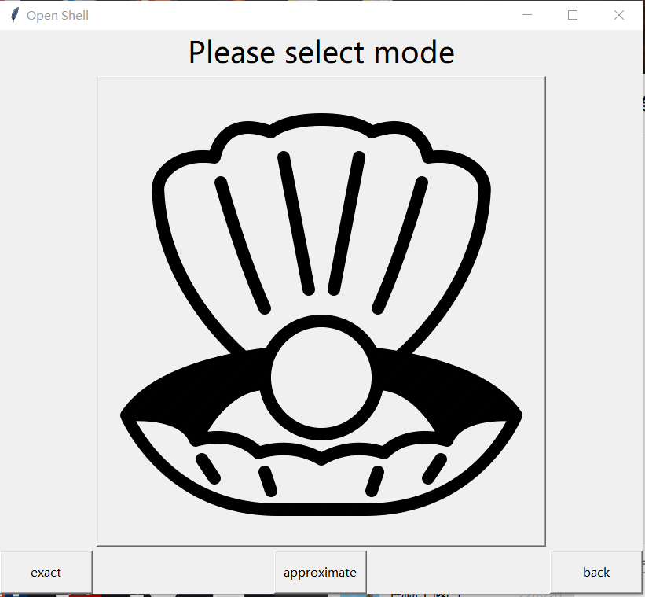
exact: Output all combinations in accordance with the rules, suitable for the structure of less than 50 carbon atoms, high accuracy.
approximate:Monte Carlo algorithm is used for sampling, and the regular combinations in the output samples are suitable for structures with more than fifty carbon atoms, and the accuracy is low.
back:Go back to the previous page
Select the mode you need and wait for the results to appear. Don't click on other options, otherwise it may lead to a run error.

- Output Result
If you select open shell mode, the window displays the maximum Clar number、total number of combinations and the probability of a free radical on each carbon atom.
If you select close shell mode, the window displays the maximum Clar number and total number of combinations.
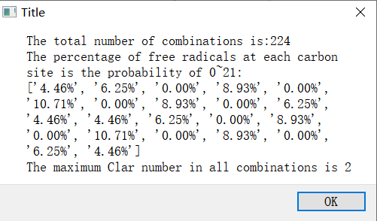
Open shell
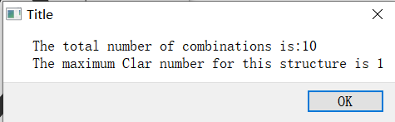
Close shell

If you want to see all the combinations and more details, open the tool.box-result file on drive C, which will output all the information you need.
